**Category Theory**

**Definition**:

Category is a collection of objects connected together by arrows or links, these arrows are called morphisms. Example: A set of natural numbers etc.

**Properties:**

* Composition: Let an object X is connected to object Y via a morphism ‘f’ and Y is connected to Z via a morphism ‘g’ than there exist a connection between X and Z called (g ◦ f).

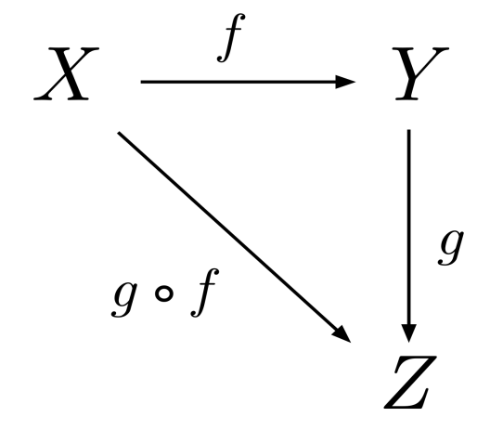

* Associativity: For each morphism f between A and B , a morphism g between B and C and a morphism h between C and D, we have (h ◦ g) ◦ f = h ◦ (g ◦ f)

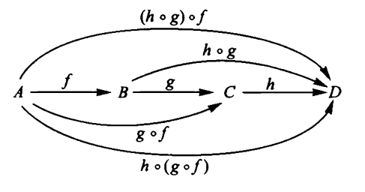

* Identity: For each A ∈ obj(A), a morphism ida from A to A, is called the identity on A, such that for each f ∈ A (A, B), we have (f ◦ ida) = f = (idb ◦ f).

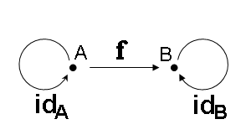

**Isomorphism:**

A morphism f between object A and B in a category then there must be an inverse of f between A and B such that f ◦ finv = id (finv is f inverse and id is identity)

**Monomorphism:**

A morphism f between object A and B in a category is a monomorphism if, for any two morphisms g1, g2 between A and C, f ◦ g1 = f ◦ g2 implies that g1 = g2.

**Epimorphism:**

A morphism f between object A and B in a category is a epimorphism if, for any two morphisms g1, g2 between B and C, g1 ◦ f = g2 ◦ f implies that g1 = g2.

**Endomorphism:**

A morphism f exist from an object A to itself.

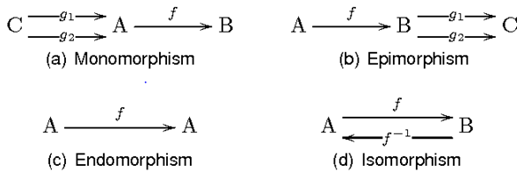

**Functor:**

It is a mapping between two or more categories. It is the mapping of each individual object of one category to other and similarly a mapping of morphism of a category to the other.

It preserves composition and identity morphism.

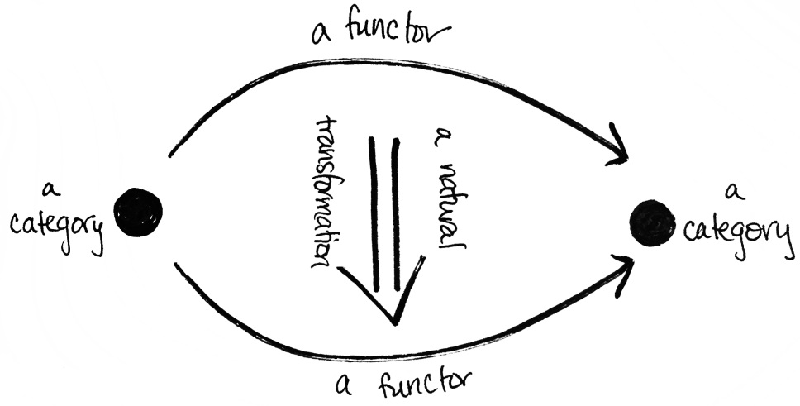

**Example of functor:**

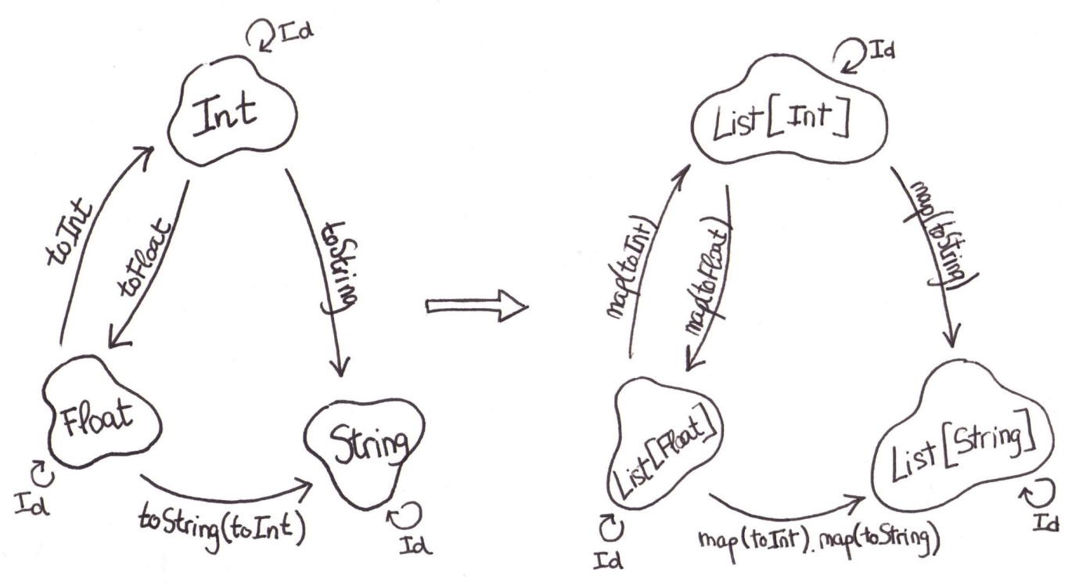

**Natural Transformation:**

A **natural transformation** provides a way of transforming one functor into another while respecting the internal structure (i.e., the composition of morphisms) of the categories involved. Hence, a natural transformation can be considered to be a "morphism of functors".